PMT Controller

Vault Folder: PMT Controller

Nathan Clack

Research Specialist

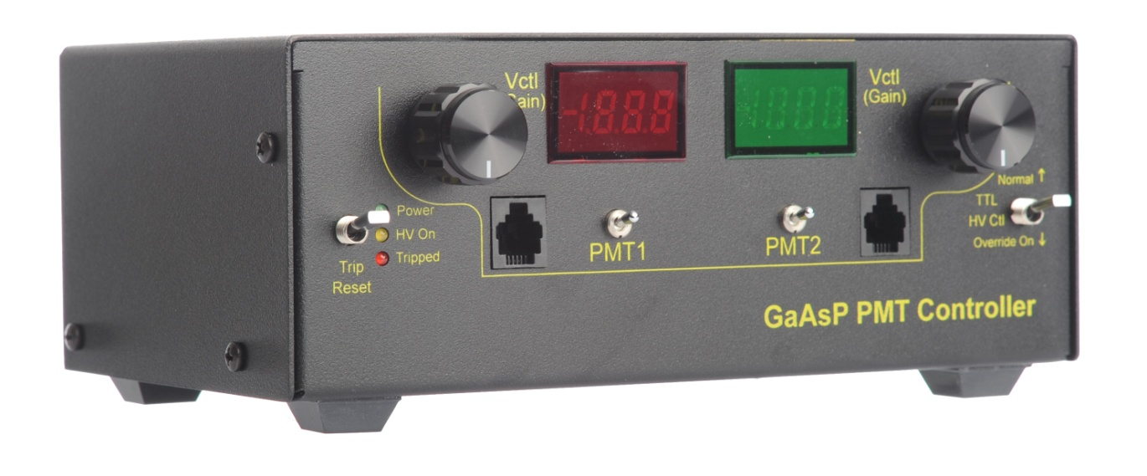

Steve Sawtelle  
Electrical Engineer, ID&F  
(571) 209-4158

Contents

System Overview 2

Hardware Development 2

Assembly, Test, and Calibration 3

# System Overview

The PMT Controller provides two channels of control for GaAsP Photo Multiplier Tubes. The low –noise design uses static logic, linear power supplies, and an AC line filters. The control voltages are independently adjustable over their entire range via a multi-turn controls, with the voltages displayed on the built-in meters. Each PMT can be switched on and off independently. A trip circuit is built-in to detect high PMT currents. Trip level and duration can be independently set for each channel. A trip condition turns off both PMTs and can be reset via a front panel control. External control of high voltage and trip reset are also provided.

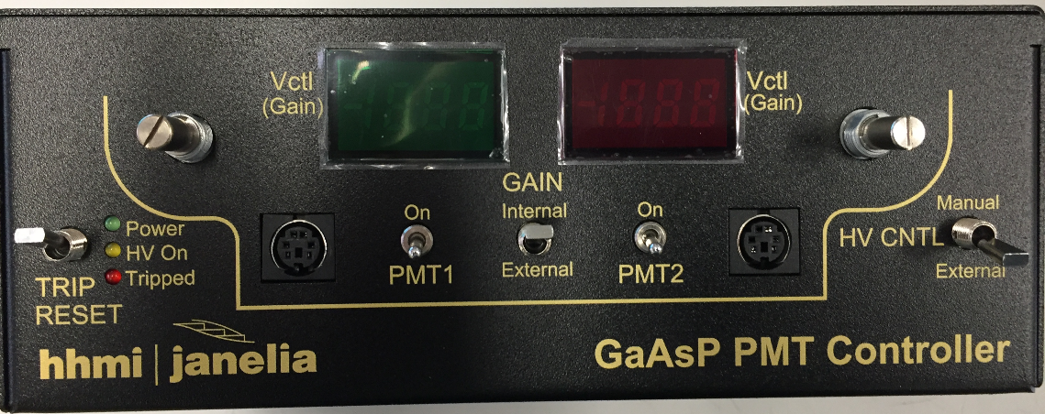

Front Panel

* Trip Reset: resets a tripped condition
* LEDs: Power On, High Voltage On, Tripped
* Vctrl: Control Voltage Setting (each channel)
* PMT connector (each channel)
* PMT1 (2): Enable control for each PMT
* HV CNTL: High Voltage control: Manual or External

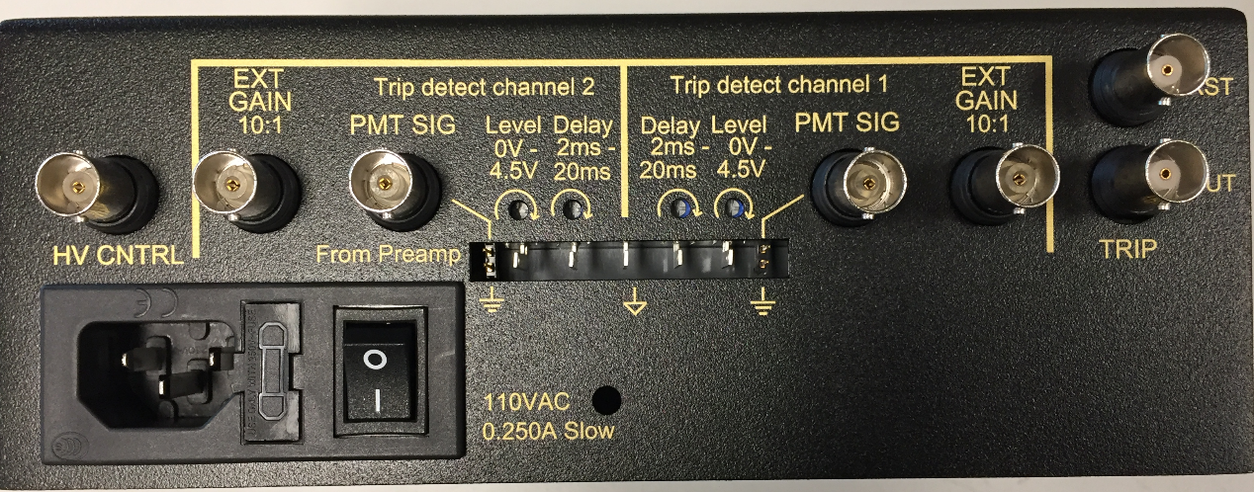

Rear Panel

* AC inlet, power switch, fuse
* HV CNTRL: External HV and trip control (Active high TTL, isolated).
* EXT GAIN: External gain control (10:1, so 1 volt in provides 0.1 gain signal) (each channel)
* PMT SIG: PMT pre-amp input for trip detect (each channel)
* Shield GND: Jumper to connect PMT SIG shield to local ground (each channel)
* Trip V: Adjust the trip detect level (monitor via test pin) (each channel)
* Trip Time: Adjust how long trip level must be active before trip (monitor via test pin) (each channel)
* GND: test point ground reference
* TRIP RST: External Trip Reset (Active high, TTL, isolated).
* TRIP OUT: Trip Out Signal (Open collector) – Pulls low when trip condition occurs

# Hardware Development

The PMT Controller is based off a previous Janelia design. Care was taken to eliminate switching noise. Only the panel meters use switching electronics.

The trip detect circuits have some high frequency noise filters (~30kHz), followed by a level comparator with adjustable threshold. This is followed by an adjustable trip delay circuit. Therefor a trip detect occurs when the input signal reaches a particular threshold and lasts a certain duration. The two trip signals are OR’ed together to create single trip event if either input satisfies the trip requirements. This in turn sets a latch to turn off the high voltage control and a trip indicator LED. The trip condition can be reset using the Trip Reset switch.

Each channel can be turned on and off independently. There is a common high voltage control.

*Schematic*

*Printed Circuit Board*

*Materials*

**See project file**

# Assembly, Test, and Calibration

The PMT Controller is designed to require a minimum amount of wiring; most components mount directly to the main PCB.

**General Assembly Notes**

The assembly requires two LCD board assemblies and one main board. The only wiring needed is for the AC input. The PMT connectors can be mini-DIN or modular. The modular connectors make this version of the controller are compatible with older versions. The mini-DIN provides shielding and allows cables to be extended easily.

**Enclosure**

The “.PDA” file is a file used by Protocase, Inc. to fabricate, paint, and silkscreen the enclosure.

**Power**

The AC power from the power entry module must be wired to the board with stranded 18 AWG wire. Observe standard AC wiring practices and refer to the photo:

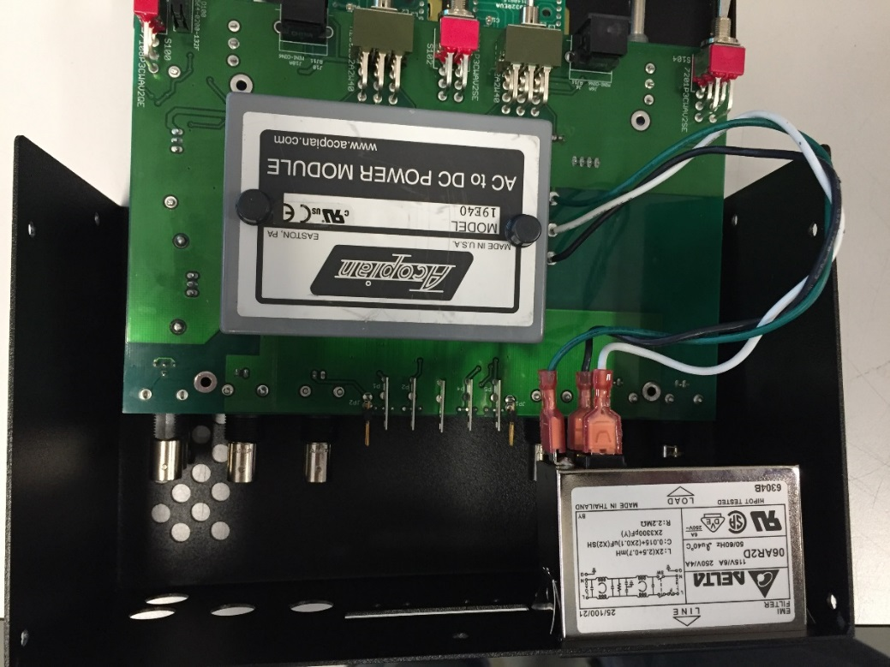

**LCD**

The LCD displays connect to the main board via jumper cables: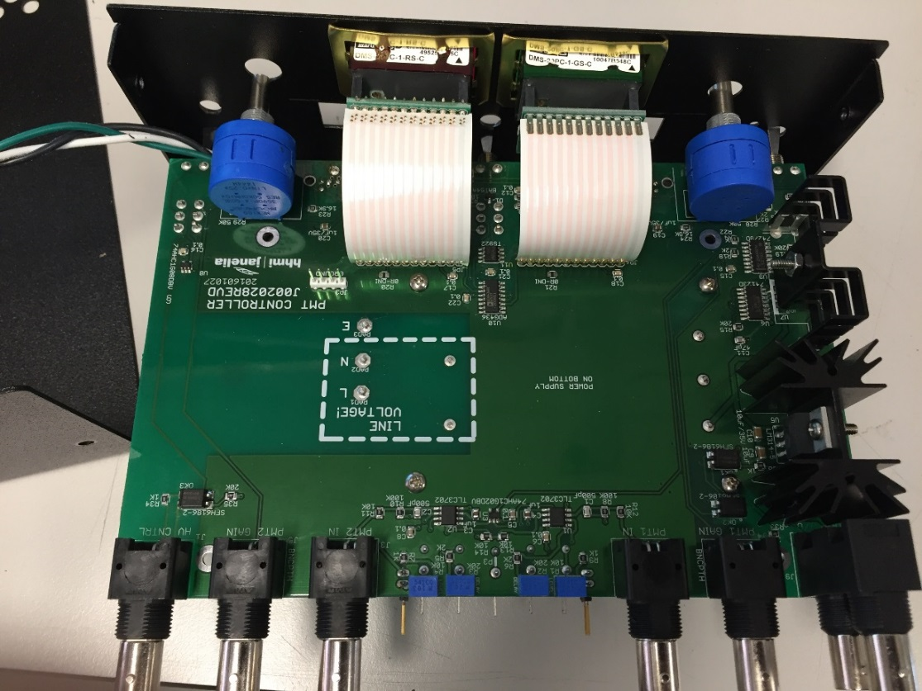

**PMT Connection**

There are two possibilities for the PMT connector: the original RJ-style or the new mini-DIN. The mini-DIN provides shielding and may reduce noise.

Mini-DIN Pinout

The mini-DIN connector allows one to attach the PMT using a commonly available cable assembly (such as Tensility 10-00422, Digi-Key 839-1051-ND). Extension cables are also readily available (Tripp Lite P222-006 – Digi-Key TL418-ND).

|  |  |
| --- | --- |
| **Pin** | **Function** |
| 1 | Power |
| 2 | Gain |
| 3 | Ground |
| 4 | Reference Voltage |
| 5 | Not used |
| 6 | Not used |
| Shield | Ground |

Modular Jack (RJ) Pinout

|  |  |
| --- | --- |
| **Pin** | **Function** |
| 1 | Gain |
| 2 | Reference Voltage |
| 3 | Ground |
| 4 | Power |

**PMT Controller Test Procedure**

*System Setup*

1. PMT Controller
   1. Time trip potentiometer set to a minimum of 2ms
   2. Trip voltage potentiometer set to about 0.4V
      1. This can be measured using the test points; the center test point is ground
      2. It can also be set by pointing the two dots on the potentiometer in the 9 o’clock position
      3. This potentiometer ranges the trip voltage from about 0 - 4.6V
2. Pre-Amp – Stanford Research Systems SR570
   1. Make sure low noise is selected, 5µA/V, and invert are on/selected
   2. The filter, input offset, and bias voltage should all be off

*Testing without the PMT*

1. Using the 4 pin test cable check for noise in the power supply (J5, J6). Noise should be in the range of 5mV to 20mV peak to peak.
   1. This can be done by measuring between pins 1 and 2 of J5 and J6 with an AC Coupled channel.
2. The power supply for J5 and J6 should be at 15V.
3. Resistance across pins 2 and 3 of J5 and J6 should be 66kΩ with PMT Controller power turned off.
   1. It should not change when the potentiometer’s value is increased or decreased.

*Testing with the PMT (p/n: ZD5760)*

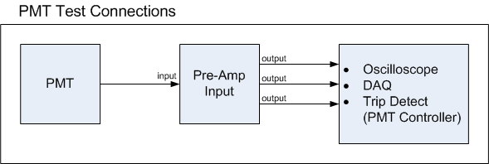

1. Make sure the PMT Controller is not tripped before beginning the testing. Red LED should be off.
2. The LCD display should show a range from about 0 – 0.9V when the potentiometer is adjusted.
   1. This sets the gain for the PMT output pulse
3. Typically will not see anything on the oscilloscope with the gain less than 0.5V. Make sure the PMT pulse can be seen in the oscilloscope
4. Test trip by lowering the gain and blocking light from the PMT with your hand. Trip level should correspond with the trip voltage you set in the system setup section.